**PHASE 3:**

**DEVELOPMENT PART 1**  
Since the Visual Recognition Service is not available (deprecated), already available resources (youtube videos) were used to grab screenshots of the process flow.

**STEP 1:** After IBM (365 days free trial)was created, Visual Recognition service is added from the Catalog.

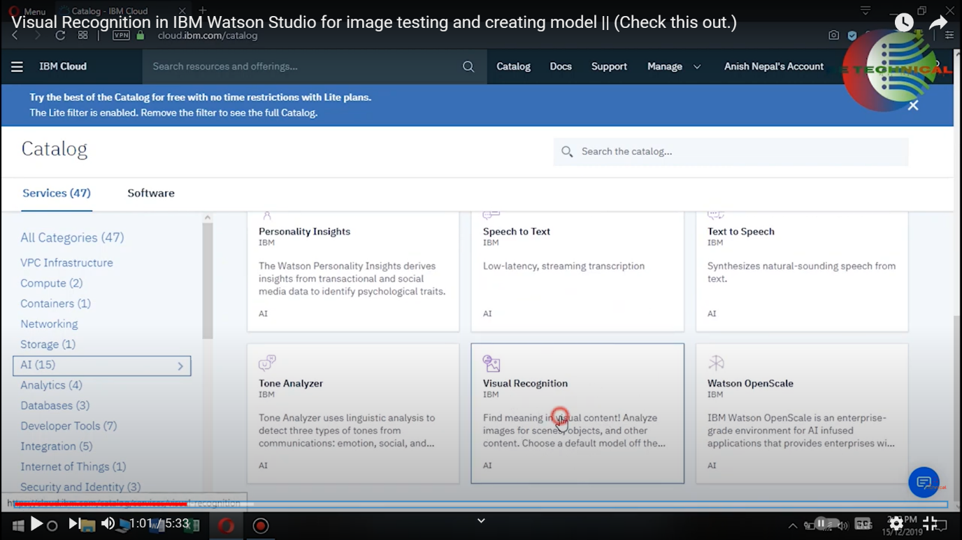

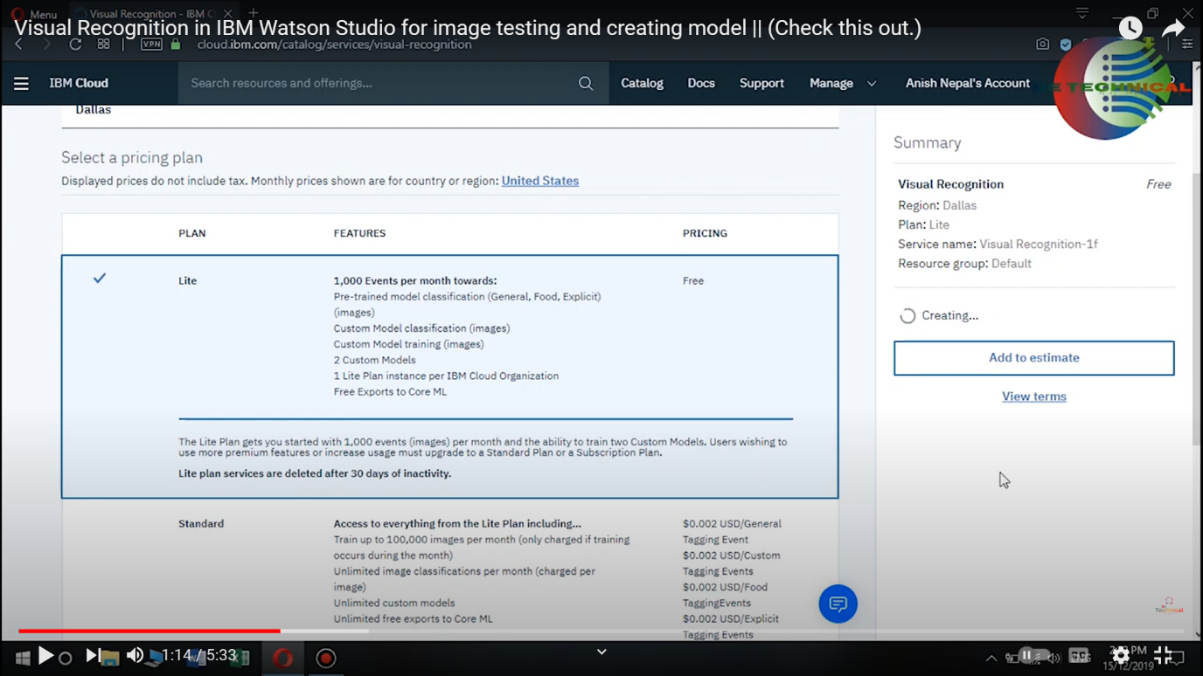

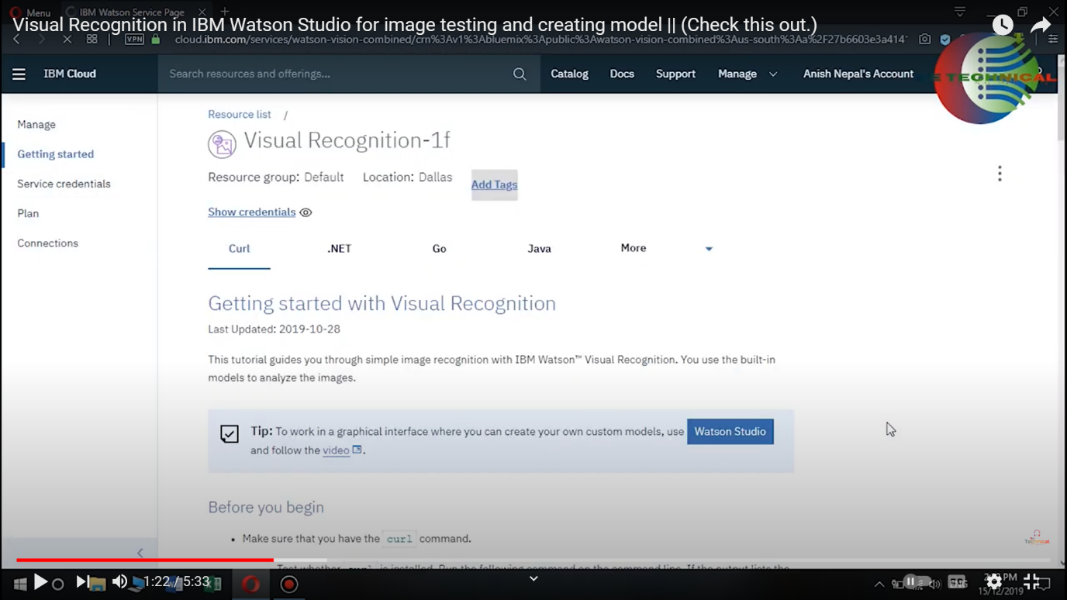

**STEP 2** : Building Image Classifying models

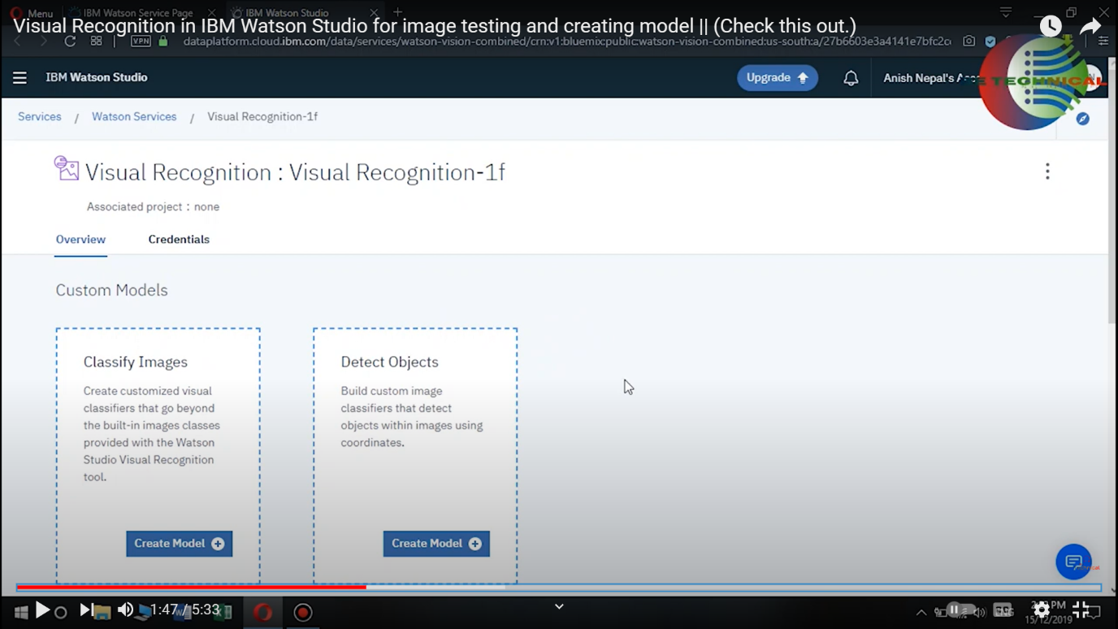

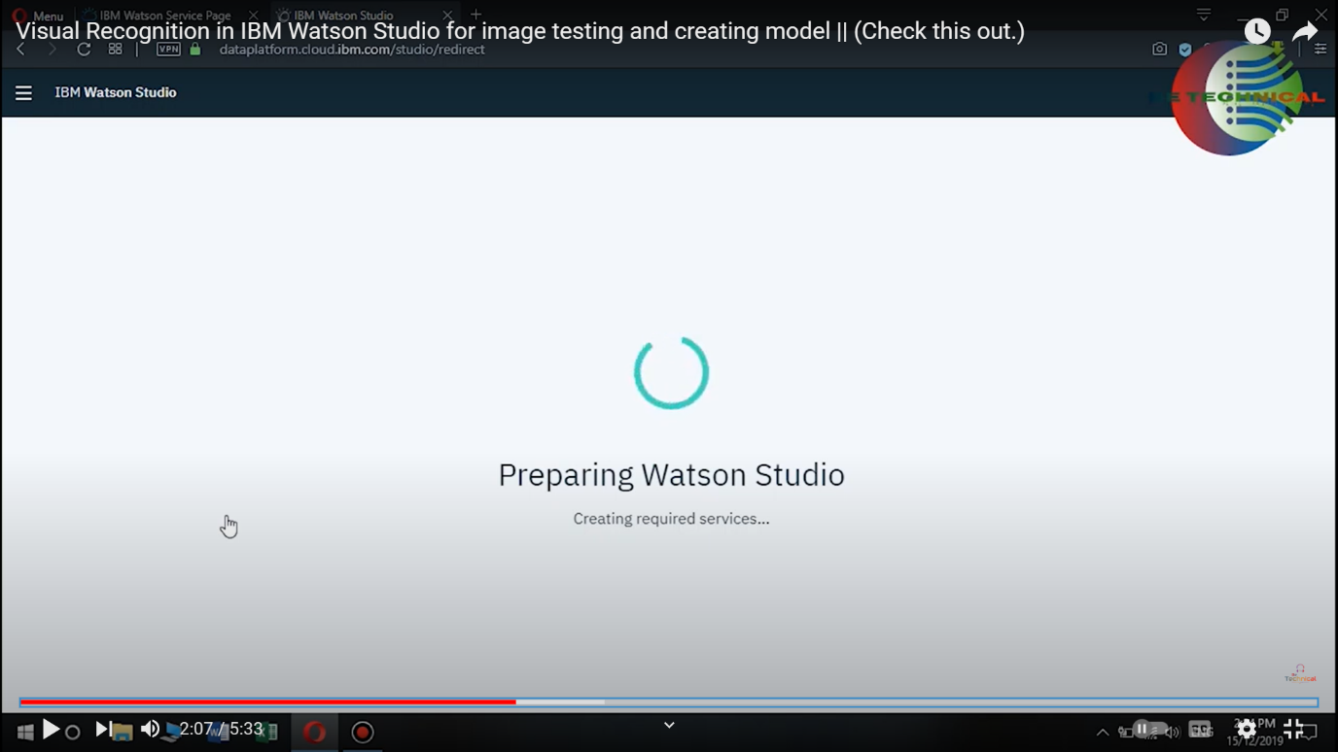

**STEP 3** : Create new project , add description.

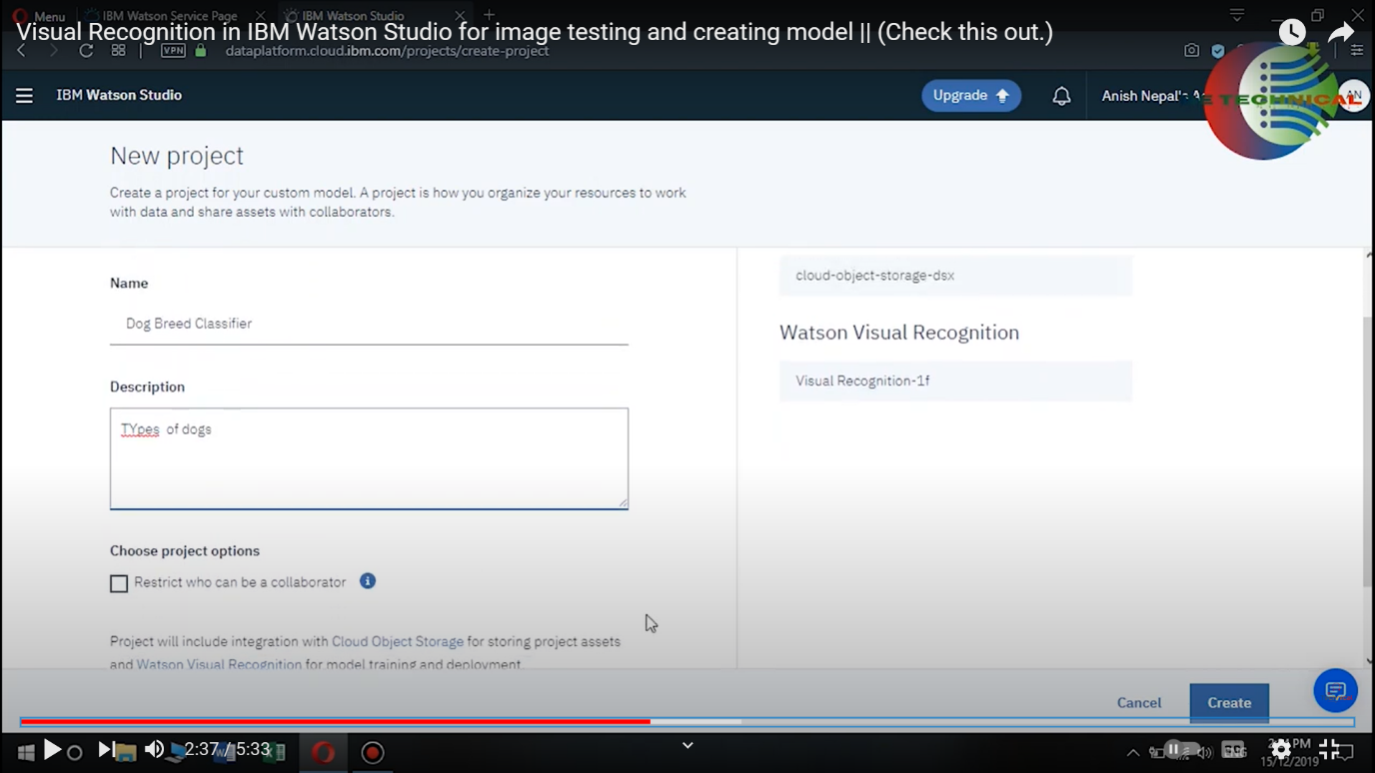

STEP 4 : Build Custom Models

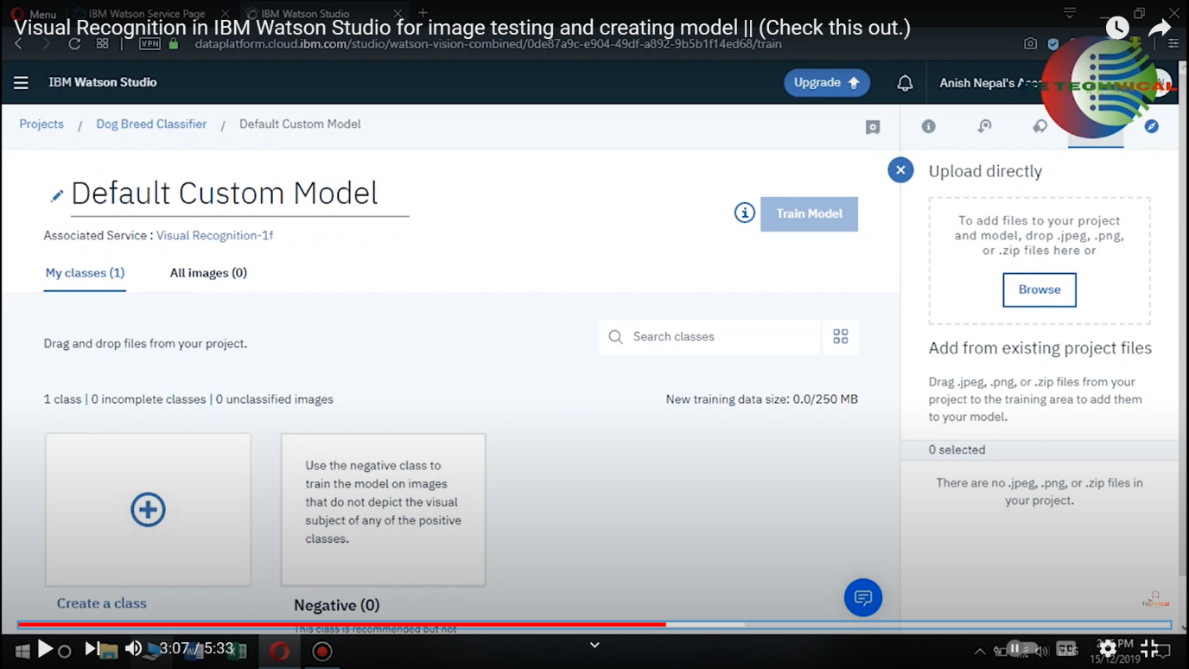

**STEP 5** : Upload training files dataset from device (custom).

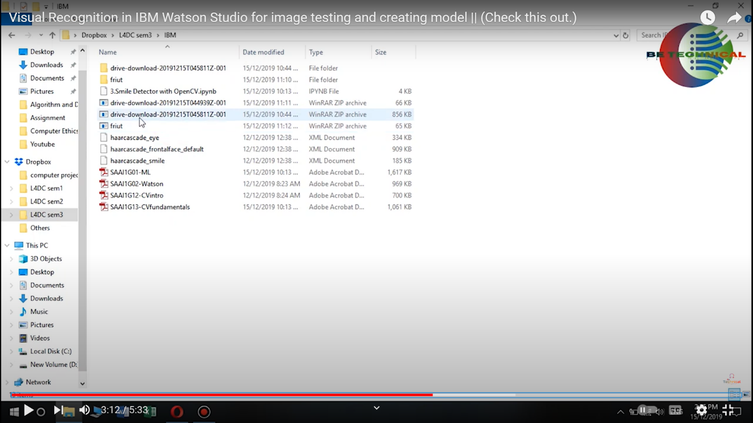

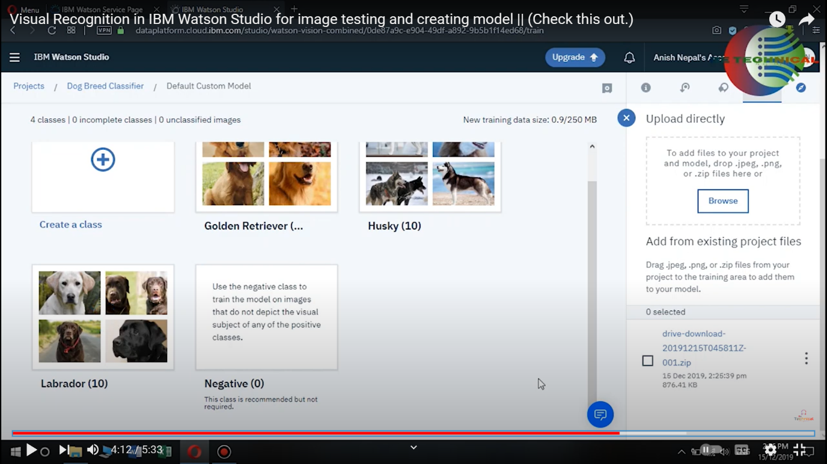

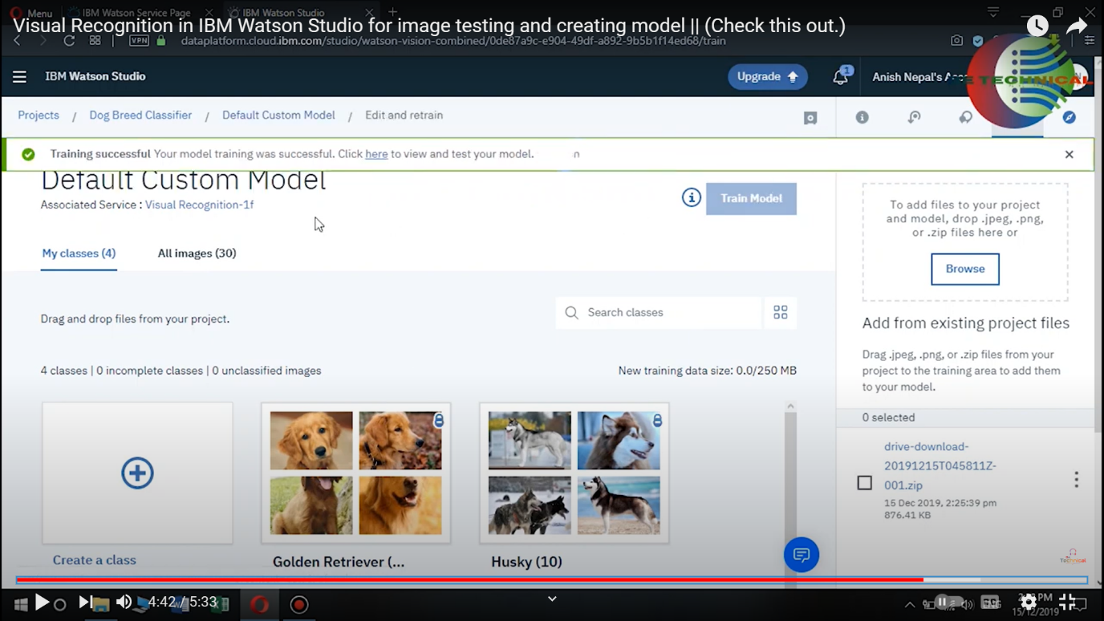

**STEP 6** : Default Custom model is built.

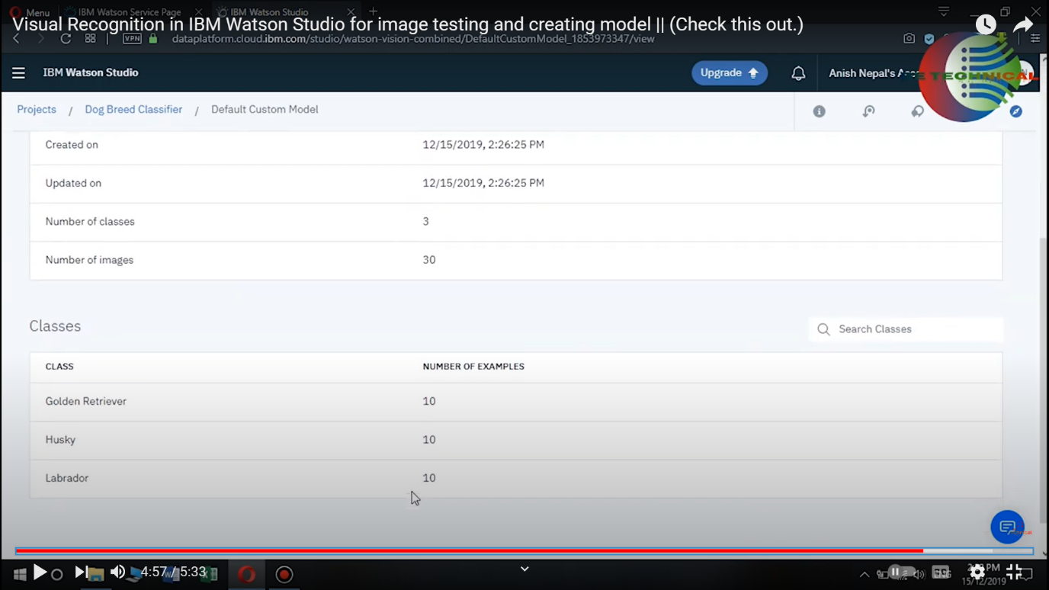

**STEP 7:** Few images are tested.

